Відділ освіти Артемівської міської ради
Міський методичний кабінет

Цикл уроків
з англійської мови
в 6-А класі за темою
« Подорожі »

Підготувала
вчитель англійської мови
Соледарської загальноосвітньої
школи I-III ступенів № 13
Артемівської міської ради
Донецької області
Кашеварова Олена Віталіївна

2015 – 2016 н.р.
Відділ освіти Артемівської міської ради
Міський методичний кабінет

РОЗРОБКА УРОКУ
з англійської мови
в 6-А класі
за темою
“ Travelling. Kinds of travelling “

Підготувала
вчитель англійської мови
Соледарської загальноосвітньої
школи I-III ступенів № 13
Артемівської міської ради
Донецької області
Кашеварова Олена Віталіївна

2015-2016 н.р.

Урок № 1 Дата: 19.11.2015
Тема: «Подорожі»
Підтема: «Подорожі. Види транспорту»
Задачі:
- практичні: ввести в мовлення нові лексичні одиниці та закріпити за допомогою усного вправління; організувати монологічне мовлення учнів на рівні мікровисловлювання з опорою на mind-map; організувати читання тексту “Travelling” з метою отримання основної інформації; організувати аудіювання учнями тексту “Little Red Riding Hood`s Trip” у пред′явленні вчителя, навчити сприймати на слух основний зміст тексту;

- формувати комунікаційну мовленнєву компетенцію; стійку мотивацію до вивчення англійської мови.
- розвиваючі: розвивати довготривалу, оперативну пам`ять, логічне мислення; здатність самостійно побудувати мовленнєвий вчинок на рівні фрази та надфразової єдності; удосконалювати якість вимовних навичок в процесі читання тексту вголос; розвивати слухову короткочасну пам`ять, слуховий контроль, уяву, увагу, образне мислення;
- виховні: виховувати культуру спілкування, толерантне ставлення до співрозмовника, заохочувати до творчої ініціативи , виховувати позитивну самооцінку учнів.
Обладнання: тематичні малюнки- інфографіка, роздавальний матеріал з теми, мікрофон, аудіо запис розминки“In the Bus”, медіа презентація по темі ,“Kinds of travelling”, проектор
Тип уроку: урок засвоєння нових знань
Форми, методи, прийоми, використані на уроці: групова, парна, самостійна робота учнів; інтерактивний метод «Мікрофон», сюжетна гра «An interview».

25
Хід уроку:
I. Початок уроку:
1) Організаційний момент:
Teacher: Good morning, dear children! Good morning, dear guests! I am glad to see you here today!
Today we are going to speak about travelling. The theme of our today`s lesson is “Travelling. Kinds of transport”. Nowadays many people travel all over the world. Why do they travel? What is the best mean of transport? All these questions will be answered today.
2) Мовленнєва розминка:
Do you like to play? Let `s play game together. Imagine that I am a journalist of the magazine “All Over the World” and I want to ask you some questions for my magazine. Are you ready to answer? So let `s start.
1. Do you like to travel?
2. Where and when did you go last time?
3. When do you usually travel?
4. Whom do you like to travel with?
5. Do you find it useful or not?
6. Do you like to take pictures when you are travelling?
Teacher: Thank you very much! Good work! I see you really like travelling!

II. Основна частина:
- Speaking
Teacher: Travelling is very popular nowadays. So, why do people travel? What do you think? (на дошці прикріплений аркуш ватману в центрі якого фраза “Why do people travel?”)

- Teacher: Look at the blackboard, please. You can see the question “Why do people travel?” Let`s try to answer it. I will take the falt-pen and write down your ideas. It will be our mind-map.

26

MIND-MAP:
to study geography to have a rest to see different
countries

WHY DO PEOPLE
TRAVEL?
to visit friends for pleasure

to be fond of travelling on business to know something
interesting

- Let`s look through all the reasons one more time. Translate, please: відвідати друзів, відпочити, для задоволення, по справам…

- Great job! And now I want you to make up a short story according our mind- map.Who wants to begin? (1-2 учня – монологічне мовлення з опорою на план)

Teacher: We found out so many reasons why people like to travel!
But which way can they do it?

2) Vocabulary Presenting
(використання computer presentation-електронний додаток 4)

Teacher: So, to speak about different kinds of travelling we should review some words and word-combinations. Look at the screen, please. So, to speak about different kinds of travelling we should learn some new words and word-combinations. Look at the screen, please.

- At first, let`s pronounce them correctly. Say after me : a plane, a train, a car, a ship, a bus, a tram, a trolley-bus, a bicycle, a motor bike, a taxi, metro.
(presentation- part 1)

- Secondly, pay attention to the prepositions (прийменники) by, on: we use the preposition by after all kinds of travelling: by ship, by car, by bus… But we travel on foot. Let`s try to choose the necessary preposition practically
(presentation-part 2)

27

3) Vocabulary Practice:

- Use the infographics on your desk. And one by one tell me, please, how we can travel (використання інфографіки )
Examples: We can travel by bus, by car……, on foot.

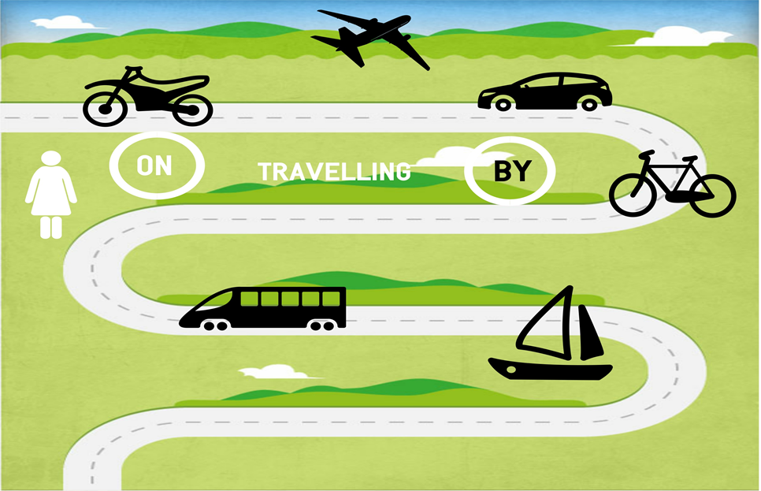

Teacher: Excellent! Thank you!

- It`s high time to play. The game is called “ Microphone”. I`ll give you this microphone and your task is to tell us about your favourite way of travelling using it (presentation – part 3)

You can begin with the words:
- I like…
- I prefer…
- My favourite way of travelling…
But only that student can speak who has a microphone. Let`s start.

4)Relaxation

Teacher: As we talk about travelling today, I want we` ll have a rest, and to make an imaginary trip. Today we are going to Zanzibar. We worked hard, we got tired and decided to lie in the sun and to swim in the sea. So now we are at the bus stop. Oh, our bus is running!!!

- Розминка з рухами “In the Bus” ( використання аудіо фізкультхвилинки- електронний додаток 5)
28
- Teacher: Our trip was pleasant, comfortable, and at last we arrived to Zanzibar. Go to the blackboard, please. Make up a circle, put your hands on your classmate`s shoulders. Listen to me and do the actions.

The Weather In Zanzibar

The weather in Zanzibar is hot. The sun is shining.(діти масують плечі товариша попереду). A light wind is blowing.(погладжують по спині) Suddenly it started drizzling.(учні легенько постукують один одного по спині) The dark clouds covered the sun. Oh, no! It is hailing!!! (починають стукати сильніше) But look! The sun is shining again! (знову масують плечі)

Teacher: I hope you are ready to continue working now. Take your seats, please.

4) Reading

- Teacher: When we are going to travel we must decide which kind of transport to choose. But, you know, each kind of travelling has its own advantages and disadvantages. To know about them we should read the text “Travelling”

Text for reading “Travelling”
People like to travel. They travel by plain, by train, by bus, by boat, by car. But each kind of travelling has its own advantages and disadvantages. The fastest way of travelling is by plane. You can get to other country in a few hours. Travelling by train you can see the country you are travelling through and not only the clouds as when you are flying. There are sleepers and dining-cars in passenger trains which make even the longest journey enjoyable. Some people like travelling by ship. You can see even dolphins in the sea. But you can feel bad if you have seasickness. Many people like travelling by car. You will never miss your train or plane, you can make you own time-table, you can stop wherever you wish. But the best ways of travelling are travelling by bicycle, by motor bike or on foot. You can follow narrow trails in the field or in the woods where there are no roads. You can hear birds sing, listen to the sounds of nature, to enjoy the fresh air. Besides it is useful for our health. But you can wet through when it rains, you can not use bicycle or bike in winter.

Teacher: Thank you very much!

Now I want you to devide into 4 teams: Green team, Red team, Yellow team, Blue team (Діти сідають за столи відповідного кольору)

- So, we have 4 teams today. And the first task is to fill in the gaps, using the text. You have 1 minute. Start working

29

Example:
Card 1
If you want to get to other country as quickly as possible you should travel by…
You will never miss the train using the…
Travelling by… has a big disadvantage: you can have a seasickness

Card 2
People prefer travelling by… because it is the most comfortable kind of transport
You can go there where are no roads, travelling by…
The disadvantage of the… is that you can see only the clouds.

Card 3
When we sail across seas and oceans we travel by…
If you want to see the country you should use the …
Travelling on … is very useful for our health.

Card 4
If you want to enjoy fresh air you should travel on…
There are sleepers and dining-cars in the …
But you can not travel by… when it is raining because you` ll wet through.

Teacher: Let`s check your work. Wonderful! Thank you!
5) Writing.
Pair work.
a)Teacher: Oh, no! Look at this mass of letters! I prepared a very interesting task for you. But unfortunately all letters mixed. Could you help me to unscramble the words?
30

Write the names of transport correctly in your exercise-books:
1. sihp 5. cyclebi
2. naitr 6. sub
3. nelap 7.toof
4.cra
Teacher: Are you ready? Let`s check. Oh, thank you! You helped me so much!
- All the words we need for our following task are correct now. Choose the card with the name of transport. And I want you to match it with its advantages and disadvantages (розрізати за лініями)
Transport | Advantages | Disadvantages
Plane | The fastest way of travelling  Comfortable | To feel bad  To see only the clouds
Train | To see the country  There are sleepers and dining-cars  Comfortable, not expensive | Rather slow
Ship | To breath the sea air  To see dolphins | Rather slow  To have seasickness
Bus | Cheap  Comfortable  To travel with company | To feel bad
Car | Comfortable  To make own time-table  To stop wherever you wish | To feel bad  To take just 4 persons
Bicycle | Useful for health  To go there where is not road | To wet through  Not for a long distance
On foot | Useful for health | To wet through  To cold

You have a minute.
Teacher: Have you already done? Read your variants
7) Auding
a) Now I want you to listen to the text ” Little Red Riding Hood`s Trip”. During the listening you should make a map of the girl`s way according. Step by step.

31

Text for listening “Little Red Riding Hood`s Trip”
Once upon a time there lived a little girl, her name was Little Red Riding Hood. One day her mum cooked tasty pasties and asked the girl to bring them to her grandmother. At first Red Riding Hood went on foot, she picked many beautiful flowers, then she got tired and took the bus to the railway station.

She went by train to the airport and flew by plane over the mountains.
Then the girl took a taxi to the harbour and sailed by ship across the sea. At last she cycled to her granny`s house and they had a tea with pasties.

Teacher: Write the names of the transport in the circles in order you have known from the text (використання інфографіки)
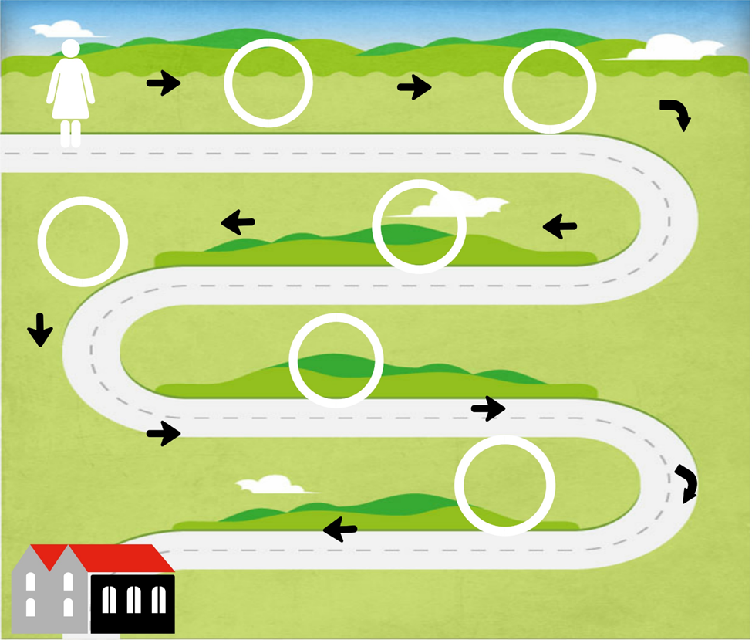

Teacher: Have you already finished? So, let us see your pictures.
32

III. Підведення підсумків уроку:
Teacher: Our time is over. I hope you liked today`s lesson. We have learnt many words, got much new information. Some of you worked very hard , were very active, helped me a lot, so I give you excellent marks: прізвище-оцінка
Some of you took an active part in our conversation but there were some mistakes in your speech, so your marks are:

- Домашнє завдання:
Your hometask is to learn the names of transport. And I want you to draw a picture of your favourite kind of transport for the next lesson. Is it clear for you? So, thank you very much, it was my pleasure to work with you today!

33

