PROCEDURE
I. GREETING
Teacher: Dear friends! Ladies and gentlemen! I am very glad to see you here today. Welcome to our contest “ Britain in brief ” and I hope you will enjoy it.

II. INTRODUCTION
Teacher: I want to introduce the participants of our today`s meeting. They are the students of our school who love English very much. Meet them.
Tell us about you in a few words, please (коротка учнівська розповідь про себе)
Teacher: Thank you very much. Take your seats, please. Let me introduce our honorable jury who will judge today`s contest (2-3 members).
Our quiz consists of blocks of questions. Your task is to choose one correct answer among several variants and fill in the blank. You will get 1 point for each correct answer.
So, let`s start!

III. MAIN PART
PART 1
1. The United Kingdom of Great Britain and Northern Ireland consists of 4 parts: England, Scotland, Northern Ireland and…
a)Canada c) Wales
b)Mexico d) Australia

2. As you know England is a country of forests and plains ( рівнини), Scotland is the most mountainous region of the UK and the region of…
a) lakes c) rivers
b) fields d) hills

3. On the map of the UK we can see that three parts of Great Britain are situated on the British Isles, but this part is located on the other island. It is…
a)Scotland c) England
b) Northern Ireland d) Wales 53
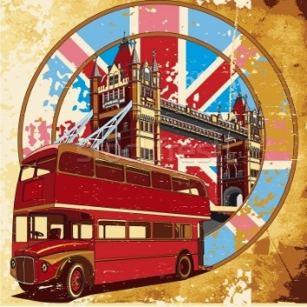
4. The head of the United Kingdom is…
a) the presedent c) the queen
b) parliament d) the prime-minister

5. The national emblem of this country is a red rose
a) England c) Northern Ireland
b) Wales d) Scotland

6. This plant saved Scots from the death and invasion( завоювання), because one of the Norsemen who wanted to invade Scotland stepped on it and screamed. It is …
a) a red rose c) an yellow daffodil
b) a shamrock d) a thistle

7. Welshmen ( валійці) all over the world wear their national emblem-shamrock on their national holiday
a) St. George`s Day c) St. Andrew`s Day
b) St. David`s Day d) St. Patrick`s Day

8. London, the capital of the UK, is devided into parts. There are
a)3 parts b) 5 parts c) 2 parts d)4 parts

PART 2
1. Union Jack is the national …
a) emblem of the UK c) anthem( гімн) of the UK
b) flag of the UK d) holiday of the UK

2. The highest mountain of the UK is.
54
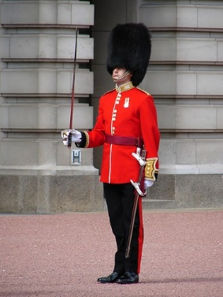
a) Snowdon c) Ben Nevis
c) Sawel d) Scafell Pike

3. The longest river of the UK is…
a) the Thames c) the Clyde
b) the Severn d) the Trent

4. Enlishmen have sentimental love for things and traditions because they are...
a) Interesting c) new
b) old d) remarkable

5. Every day at 11.30 a.m. at Buckingham Palace you can see the ceremony of…
a) Greeting the Queen c) raising the flag
b) Changing the Guard( зміна караула) d) ceremony of keys

6. Englishmen keep traditions even in food.Every day at 5p.m.they gather to …
a) cook turkey c) eat pudding
b) fry potatoes d) drink tea

Teacher: While our jury is counting the results, let`s see the presentation “Interesting Facts About England”. Be attentive, please. Bonus question will wait for you!
(презентація, електронний додоток №9)
So,the bonus question is which national musical instrument accompanied the video?
Answer: the melody of bagpipes (волинка)

55
PART 3
1.The United Kingdom is a constitutional monarchy, the country is reigned by the queen. Her name is…
a) Anne b) Margaret c) Elizabeth d) Diana

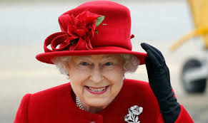
2. Queen Elizabeth II was born in 1926 and became the queen after the death of her father George VI, when she was…
a) 18 b) 26 c) 42 d) 52

3. The present Queen has…
a) 3 children b) 4 children c) 5 children d) 6 children

4. Prince Charles is the eldest son of the Queen Elizabeth II and Prince Philip. He has 2 sons William and Henry. His former wife was…
a) princess Anne b) princess Margaret c) princess Diana d) princess Elizabeth

5. It is the official London residentce of Her Majesty (Ії Величності) and her family.The first monarch( монарх), who took this residence was Queen Victoria.
a) Westminster Abbey b) Tower of London c) Buckingham Palace

6. The Royal Standard ( flag flying over Buckingham Palace) is the sigh( знак) that…
a) the Queen is in the residence b) she is absent from London
c) she is busy c) she has a rest

7. The British Prime Minister lives at…
a) 12, Whitehall b) 10, Downing Street c) 7, Russell Street d) 15, Oxford Street

8.Whitehall is…
a) a street leading from Trafalgar Square to the Houses of Parliament
56
b) a big hall in the centre of London c) a white palace wherevthe Queen lives in summer

PART 4
1.Liverpool is one of the greatest seaports of Britain. But also it is known as a birthplace of…
a) the Beatles b) Abba c) Spice Girls

2. Stradford-on-Avon is situated in the centre of England.The greatest dramatist and poet of England was born there.
a) G. Byron b) R. Kipling c) W. Shakespeare d) A. Milne

3. It is very old town, it is famous for its universities. The name of this town means the part of the River Thames where the oxen forded( овці переходили річку )
a) Cambridge b) London c) Cardiff d) Oxford

4. This town is a centre of education and learning. Newton, Byron, Darwin, Rutherford and many other scientist and writers were educated here.
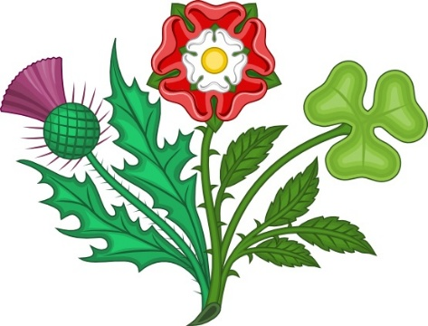
a) Cambridge b) London c) Cardiff d) Oxford

5. The Palace of Westminster usually known as …
a) St. Paul`s Cathedral b) Buckingham Palace c) the Houses of Parliament

6. Big Ben is a biggest clock bell in Britain. It was cold so after Sir Benjamin Hall, who hoisted ( підіймати ) up the bell.Big Ben was his…
a) Nickname b) Surname c) First name
7.This stone building was a palace, a prison, a fortress. Now it is a museum, where the Crown Jewels( скарби корони) are kept.
a) Westminster Abbey b) Tower of London c) Buckingham Palace c) Big Ben
57
8. Nearly all kings and queens are crowned and burried there. The 1st king who established tradition of coronation here was William the Conquerror
a) Westminster Abbey b) Tower of London c) Buckingham Palace c) Big Ben

PART 5
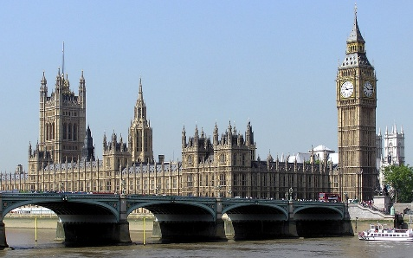
1. Christmas in Great Britain is one of the most favourite festival.It is celebrated on the…
a)December,25 b) November, 31
c) April,1 d) January,7

2. The biggest Cristmas tree in England stands…
a) Opposite the Houses of Parliament b) in Trafalgar Square
c)In front of St. Paul`s.Cathedral d) In the Tower of London

3. To get small presents and candies on Cristmas children in Britain hang on the bеd their…
a) coats b) caps c) stockings d) boots

4. People believe that ghosts( привиди) and witches (відьми) go in the streets in the evening of October 31, this day is famous as…
b) New Year b) Christmas c) Valentine`s Day d) Halloween

5 To frighten (відлякати) the witches and ghosts off people make the lantern out of …
b) Pumpkin b) cabbige c) water-melon d) melon
6 People gave a nickname to that lantern. They call it…
b) John b) Jim c) Jack Jerry

7. On the 14th of February people celebrate St. Valentine`s Day. This day was called so after…
58
a) Roman emperor (імператор)
b) Christian prist c) young king Valentine by name

8. Valentine`s Day is a festival of…
a) Sweethearts b) husbands and wives c) children d) old people
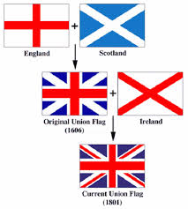
Teacher: While our jury is counting the results, let`s look at the screen. You can see the correct answers there. (презентаця, електронний додаток №10)
You have worked hard today and I am sure you have learnt many new things about Britain. In a few minute we will know the name of our today`s winner.
Now the word of our honorable jury…

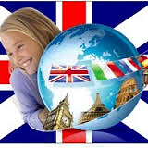
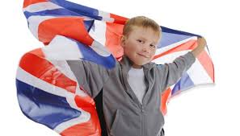

59

